Faculty Assembly Committee on the Budget Report for April 2024
The FACB met in its role as the faculty representation on the University Budget Advisory Committee on March 20, 2024.
UBAC leadership engaged in a consultative process across multiple modalities and constituencies, including FACB members among their college colleagues, as partially recounted on Slide 7 of UBAC Meeting 3.20.2024 FINAL.v21. There were many differing points of view, but the preponderance of preferences supported the plan below:
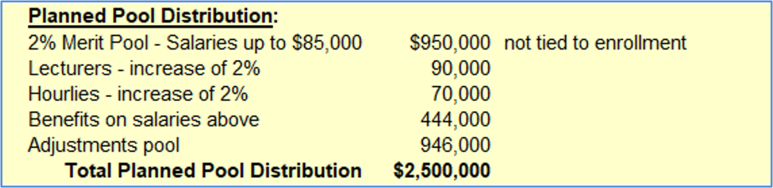
+1% Merit Pool for Salaries >$85,000 if new enrollment revenue >$1.5M​ at fall census
This plan will result in budget cuts $2.5 M higher than the cuts would be if there were no merit increases or salary adjustments. Members of the FACB, whatever their individual views of what was best, agreed that this was a fair representation of the constituent feedback UBAC received.
The JBC has approved continuation of the state funding for the Cybersecurity Initiative for three more years. The UCCS share of that funding (multiple institutions are involved, but UCCS is the lead) is $2.8 M per year, the same as it has been since the beginning. That means that the campus will not need to pick up funding for the faculty positions, as agreed to in the original grant agreement, until fall 2027, reducing the amount we would need to cut by roughly $800,000.
The result of those two decisions is that the probable shortfall between revenues and expenses for FY 2025 (next year) is now understood to be $4 M.
Rather than continue the practice over the past two years of across-the-board cuts, leaders of the divisions and colleges on campus were asked to provide expense reductions at different levels of severity, including explanations of the degree of harm that would likely occur at each level if implemented. Remarkably, this produced a preliminary estimate that the expense reductions can be achieved without asking for deeper cut scenarios and with allowances made for instances where a proposed level of cuts would be especially harmful. This is not the end of this process, but the beginning. UBAC will receive a fuller report on likely cuts at the April 24 meeting.
Since the March UBAC meeting, the voluntary retirement incentive program has been released to the campus. The impact of retirements on next year’s budget and, more importantly, the amount of any initiatives that transition to the base budget over the following two years is not known. Ultimately, though, it is likely to free up millions of dollars in savings that can be used to address those needs.
As promised, you now have access to a more complete accounting of the initiative funding that will be ending over the next three years (slide 33), as well as any costs associated with continuing initiatives past the expiration of non-continuing funding (slides 34-39), which includes reserve-funded activities not tied to initiative funding.
Bottom line: If we continued the funding for all these activities indefinitely, the cost would total $12 M. There is no expectation that everything included here will continue to be funded.
There are several steps that will be taken between now and December of 2024 to make decisions about what will happen with the activities that currently have one-time funding, but no base funding:
- Campus Priorities Conversations to determine what faculty, staff, and students at UCCS value, want to preserve, want to stop doing, and want to start doing (yes, that means there could be more new things to fund); Next two sessions are on April 22
- Collection of relevant data over the summer
- Annual Budget Reviews at the unit level to better understand what’s currently funded and what’s needed in early fall
- Presentation of the data gathered to support decision-making in the fall
- Finalize the discussion of priorities across the identified needs in late fall
- Create a multi-year plan to implement those priorities over the following three years
We also reviewed and recommended approval for two “new” programs:
- Splitting the existing Master of Science in Mechanical and Aerospace Engineering by clarifying that the current degree is in Mechanical Engineering and naming a new master’s degree in Aerospace Engineering. Will allow better recruitment and attract funding for students from non-UCCS sources.
- Replacing the current Track in Visual Arts in the Bachelor’s of Visual and Performing Arts with a new bachelor’s degree in Visual Arts. Will attract more students who now don’t realize we have such a program and allow graduates to make it clear to potential clients or employers that they have a more specialized degree.
Neither degree will have costs unless additional enrollments materialize.
Onward,
David

